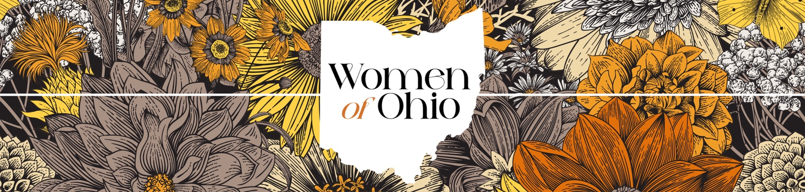

Women of Ohio Competition Entry Form
Opening Date: March 1st 2025 Closing Date: June 4th 2025
Name: _________________________
Email address: ________________________
Phone number: _______________________
Social media handles:
Does your submission include:
Please send completed entry forms along with your work to:
womenofohio@gmail.com
- Artwork _____________________________
- Or poetry? __________________________
Titles of Poems:
Please note: Your information will be saved only to contact you about the competition. It will be deleted once the project is complete.

- _________________________________
- _________________________________
- _________________________________
- _________________________________
- _________________________________
Titles of Artwork
- _________________________________
- _________________________________
Please sign to show that you have read the rules of the competition and abide by them.
Signature: _________________________________ Date: _________________________________
If you are under the age of 18, please have your legal guardian sign this form to give permission that your work can be presented in an exhibition and eBook should it be chosen. The age limit begins at 16+.

Signature: _________________________________ Date: _________________________________

Relationship: _________________________________ Full name: ________________________________

